

MSc Data Science Project
7PAM2002
Department of Physics, Astronomy and Mathematics

Data Science FINAL PROJECT REPORT

Project Title:
Flight Delay Prediction

Student Name and SRN:
Chandrika Madithati and 24098812

Supervisor: Klaas Wiersema
Date Submitted: 22-04-2026
Word Count: 4076
Git hub Link : https://github.com/Chandrikamadithati/data-science-project/blob/main/README.md

DECLARATION STATEMENT

This report is submitted in partial fulfilment of the requirement for the degree of Master of Science in Data Science at the University of Hertfordshire.
I have read the detailed guidance to students on academic integrity, misconduct and plagiarism information at Assessment Offences and Academic Misconduct and understand the University process of dealing with suspected cases of academic misconduct and the possible penalties, which could include failing the project or course.
I certify that the work submitted is my own and that any material derived or quoted from published or unpublished work of other persons has been duly acknowledged. (Ref. UPR AS/C/6.1, section 7 and UPR AS/C/5, section 3.6)
I did not use human participants in my MSc Project.

I hereby give permission for the report to be made available on module websites provided the source is acknowledged.

Student Name printed: Chandrika Madithati

Student Name signature : Chandrika Madithati

Student SRN number: 24098812

UNIVERSITY OF HERTFORDSHIRE
SCHOOL OF PHYSICS, ENGINEERING AND COMPUTER SCIENCE

Abstract
Airlines face many operational challenges, but none are as persistent as delays. This essential air travel service is a challenge within the aviation case study. The modern day's necessity of an aviation system is accurate delay prediction as air traffic systems have become complex in nature and external factors like the weather and operations constraints unpredictable. To solve this problem, we create a machine learning-based predictive framework that aims to classify and predict flight delays using historic aviation data.

The dataset in the study has flight performance data, delay percentage in different time frames and historical data like last year’s delay data. A comprehensive exploratory data analysis (EDA) was conducted to gather insights on the distribution of the variables as well as to study the pattern and find the inconsistency. Techniques like missing value treatment, encoding categorical variables, and feature scaling were used to prepare the dataset for modelling.

We applied numerous machine learning algorithms such as Logistic Regression, Decision Tree, Random Forest, and Gradient Boosting models. The goal of selecting such models was to keep them simple as well as interpretable. A wide range of performance metrics including accuracy, precision, recall, F1-score, and ROC-AUC were used to evaluate the models’ classification performance.

Contents
DECLARATION STATEMENT 2
Chapter 1: Introduction 6
Chapter Overview 6
Background of Study 6
Current Practice 6
Aim and Objectives 6
Importance of the Study 7
Research Questions 7
Chapter 2: Background 8
Introduction to Literature and Selection Criteria 8
Technical Background 8
Critical Analysis of Existing Approaches 8
Study 1 — Statistical vs Data-Driven Models 8
Study 2 — Scalable Machine Learning for Delay Prediction 9
Study 3 — Random Forest for Predictive Modelling 9
Study 4 — Gradient Boosting and XGBoost 9
Chapter 3: Dataset 10
Dataset Source and Description 10
Justification for Dataset Selection 11
Real-world UK data: 11
High data reliability: 11
Rich feature representation: 11
Temporal insights: 11
Exploratory Data Analysis (EDA) 11
Arrival vs Departure Delay Distribution 11
Cancellation Percentage Distribution 12
Current vs Previous Year Average Delay 13
Distribution of Average Flight Delay 13
Correlation Heatmap 14
Data pre-processing 15
Chapter 4: Ethical Consideration 15
Data Privacy and Anonymisation 15
GDPR and Ethical Approval 15
Permission and Licensing 15
Ethical Considerations 15
Chapter 5: Methodology 16
Overview of the Chapter 16
Feature Engineering and Target Variable Definition 16
Train-Test Strategy 16
Feature Scaling 16
Model Development 17
Hyperparameter Tuning and Optimization 17
Technical Explanation 17
Model Evaluation Metrics 18
Technical Explanation 18
Model Validation 18
Performance Comparison Strategy 18
Explainable AI Implementation 18
Chapter 6: Results 19
Overview of Results 19
Initial Model Performance Analysis 19
Optimized Model Performance Analysis 19
Model Accuracy Comparison 21
Explainability and Feature Importance 21
Chapter 7: Analysis & Discussion 22
Analysis of result 22
Analysis of Explainability 22
Comparison of result with literature 22
Practical Implication 23
Research Questions Addressed 23
Chapter 8: Conclusion 23
References 24
Apendex : 25

Chapter 1: Introduction

Chapter Overview
This chapter lays down the groundwork of the research by presenting the problem context, the aim of the research and research questions of flight delay prediction. The necessity of employing machine learning methodologies has also been underscored through aviation data. The structure of the report is described briefly to help the reader through the study.

Background of Study
According to the International Air Transport Association, aviation is crucial for the movement of people, goods and trade on a global scale. Flight delays continue to be operational inefficiencies for airlines and passengers. There can be a delay due to many causes such as bad weather, technical faults, air traffic congestion, and scheduling faults.

According to Rebollo J.J. (2019), delays in Flight significantly affect passenger satisfaction and add to the operational cost of the airlines. In the past, statistical techniques and averages were used for predicting delays. Although these methods can provide valuable insights into relationships between variables in a dataset, they can only take you so far.

With the growth of data availability, machine learning techniques have emerged as a more effective alternative. These models can learn from historical data and uncover hidden patterns within complex feature interactions, making them well-suited for predicting flight delays in dynamic aviation environments (Belcastro L.).

Current Practice
Most existing aviation systems still rely on rule-based approaches or simple statistical models for delay prediction. These methods typically consider a limited number of variables and do not adapt well to changing environmental conditions, resulting in suboptimal predictive accuracy.

Recent advancements in machine learning have enabled the development of more robust predictive systems capable of handling high-dimensional data and modelling nonlinear relationships. Ensemble methods such as Random Forest (Leo Breiman) and Gradient Boosting (Tianqi Chen) are widely used due to their ability to improve prediction accuracy and manage complex datasets effectively.

Aim and Objectives
The goal of the project is to develop a machine learning model that can accurately predict flight delays with good reliability. The purpose of the study is to analyze the historical flight data to identify patterns that can lead to delays.
The project aims to perform an Exploratory Data Analysis to understand the dataset better, pre-process the data to improve data quality, apply various machine learning models to compare their performance, evaluate their performance on various parameters, and find the most suitable model to predict delay.

Importance of the Study
The significance of the study would be to realising efficiency in the aviation sector. The ability to accurately forecast delays allow the airline to organize their schedule, allocate resources more effectively, and minimize disruptions. Travel planning and uncertainty will improve, from a passenger perspective, with better predictions.
Additionally, this study contributes to data science by showing the application of machine learning to solve a real-world problem. It offers a real-time methodology that can apply to many other environments that require time-based forecasting and operational enhancement.

Research Questions
RQ1:
How effectively can machine learning models such as Logistic Regression, Decision Tree, Random Forest, and Gradient Boosting predict flight delay status based on historical flight performance data?

RQ2:
Which features (e.g., delay percentages, previous flight performance, and operational metrics) have the most significant impact on predicting flight delays?

RQ3:
How does the performance of simple models (e.g., Logistic Regression) compare with ensemble models (e.g., Random Forest and Gradient Boosting) in terms of accuracy, precision, recall, and ROC-AUC?

Chapter 2: Background

Introduction to Literature and Selection Criteria
Flight delay prediction has become an important research area due to its impact on airline operations, passenger satisfaction, and economic efficiency. As air traffic systems become increasingly complex, traditional statistical approaches have struggled to capture the nonlinear and multifactorial nature of delays (Rebollo J.J.).

The literature for this study was selected based on three criteria:
- Publication in peer-reviewed journals or conferences
- Direct relevance to flight delay prediction or predictive modelling
- Inclusion of quantitative evaluation results

Technical Background

This project is based on supervised machine learning, specifically binary classification, where the objective is to predict whether a flight will be delayed. In this context, models learn a mapping between input features (such as delay percentages, operational metrics, and historical performance) and an output variable (delay status).

Logistic Regression is used as a baseline model due to its simplicity and interpretability. It estimates the probability of a binary outcome and allows direct interpretation of feature influence (Trevor Hastie).

Ensemble methods like Random Forest and Gradient Boosting are very popular because they can model very complex relationships. Random forest is a technique introduced by Leo Breiman which improves the predictive accuracy by combining various decision trees and reduces overfitting. Gradient Boosting, a development which takes place sequentially which corrects previous mistakes. The XGBoost implementation of Tianqi Chen has been shown to produce state-of-the-art performance in many areas.

Model performance is evaluated using metrics such as accuracy, precision, recall, F1-score, and ROC-AUC. The F1-score is particularly important in classification tasks as it balances precision and recall, especially when dealing with imbalanced datasets (Trevor Hastie).

Critical Analysis of Existing Approaches

Study 1 — Statistical vs Data-Driven Models
Rebollo J.J. (2014) conducted one of the earlier studies on flight delay prediction using statistical modelling approaches. The study utilised historical air traffic data, including flight schedules and operational variables, to analyse delay patterns. The authors applied regression-based techniques to model delays and reported moderate predictive performance, with accuracy levels around 70%.

The strength of this study lies in its detailed analysis of delay propagation and operational factors. However, the methodology is limited by its reliance on linear assumptions, which restrict its ability to capture complex interactions between variables.

Study 2 — Scalable Machine Learning for Delay Prediction
L. Belcastro (2016) A scalable data mining framework for predicting flight delays based on large-scale aviation data. The study included features such as climate, past delays, and operational statistics. Machine learning algorithms enabled accuracy rates above 85% which are higher than the statistical models.

Study 3 — Random Forest for Predictive Modelling
Leo Breiman (2001) introduced the Random Forest algorithm, which has since been widely applied in predictive modelling tasks, including aviation analytics. The method constructs multiple decision trees using random sampling and aggregates their outputs to improve accuracy and reduce overfitting.

The main advantage of Random Forest is its ability to handle complex feature interactions and provide feature importance measures. However, the model can become computationally expensive and less interpretable when dealing with large datasets.

Study 4 — Gradient Boosting and XGBoost
Tianqi Chen (2016) introduced XGBoost, a highly efficient implementation of gradient boosting. The model builds trees sequentially by correcting previous errors and has been widely adopted in machine learning competitions due to its high predictive performance.

The study demonstrated that boosting methods often outperform other algorithms in classification tasks. However, XGBoost requires careful hyperparameter tuning and is less interpretable compared to simpler models.

Chapter 3: Dataset

Dataset Source and Description
The dataset used in this study is the UK Flight Punctuality Statistics (2024) published by the UK Civil Aviation Authority (CAA). The dataset is publicly available at:
https://www.caa.co.uk/data-and-analysis/uk-aviation-market/flight-punctuality/uk-flight-punctuality-statistics/2024/

Data from airlines based in the United Kingdom is collected by the Civil Aviation Authority. The CAA gets frequent data on the operational performance of airlines for monitoring and reporting purposes. The dataset contains real operational aviation data from 2024 throughout the year.

The primary purpose of collecting this dataset is to monitor airline punctuality, assess delay performance, and provide transparency to regulators, airlines, and the public. It is used to evaluate operational efficiency and identify patterns in delays across UK airports and airlines.

To understand the structure of the dataset, the features can be classified into categories as shown in Table 3.1.

Feature Category | Example Features | Description
Temporal Data | reporting period, run date | Used to analyse trends and seasonality
Location Data | reporting airport, origin destination | Identifies geographical delay patterns
Airline Information | airline name | Identifies airline carriers to analyse performance differences
Flight Operation | arrival departure, scheduled charter | Describes operational characteristics
Delay Metrics | delay %, delay minutes | Measures delay severity
Target Variable | Delay Class | indicates delayed vs non-delayed flights

Table 3.1: Feature Categories in Flight Delay Dataset

Justification for Dataset Selection
The dataset was selected due to its strong relevance to the research objective of predicting flight delays using real-world aviation data.

Real-world UK data:
Unlike generic or simulated datasets, this dataset reflects actual airline operations in the United Kingdom, making the results directly applicable to real-world scenarios.

High data reliability:
The dataset is collected and published by the UK Civil Aviation Authority, a government regulatory body, ensuring data accuracy, credibility, and consistency.

Rich feature representation:
The dataset includes both numerical features (delay percentages, delay durations) and categorical features (airline, airport), allowing machine learning models to capture complex relationships.

Temporal insights:
The inclusion of reporting periods and historical comparisons enables the identification of trends and seasonal patterns, which are important for predictive modelling.

Exploratory Data Analysis (EDA)

Exploratory Data Analysis (EDA) is crucial to comprehend any dataset and prepare it for machine learning modelling. The EDA (Exploratory Data Analysis) aims to analyse the distribution of variables, find patterns, detect anomalies, and find insights between the features. This study has attempted visualization techniques based on statistical methods to explore the dataset in detail.

Arrival vs Departure Delay Distribution

Boxplot depicts the distribution of average delay minutes for departure (D) and arrival (A) flights. The graph shows that arrival and departure delays share a similar distribution with most flights experiencing low delays concentrated around the lower quartile. Nevertheless, we see quite a lot of extreme outliers, especially for departure delays which go up to over 1300 minutes. Arrival delays also present some outliers, but their magnitude does not appear to be as large.
The median delay of the two categories is close to each other. This indicates that on average flights tend to incur similar durations of delays when departing and arriving. Nonetheless, the wider distributions and larger counts of extreme values in departure delays indicate that delays at their origin tend to propagate and affect overall performance.

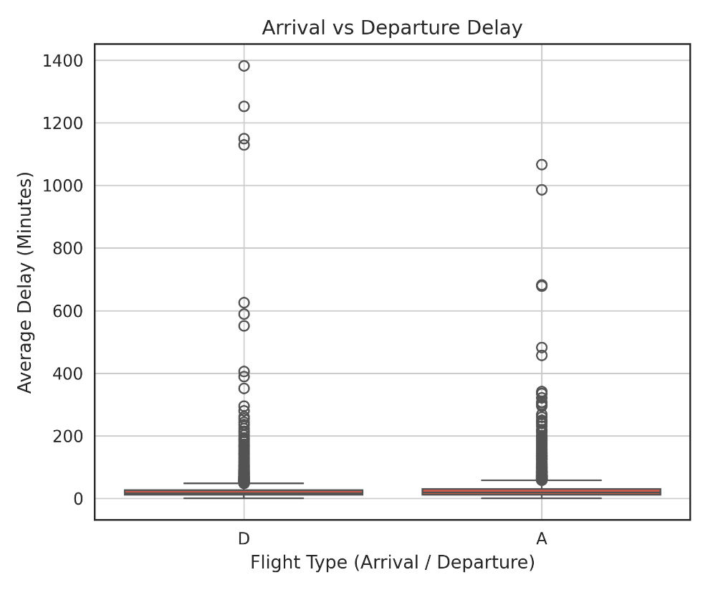
Figure 3.1: Boxplot showing the distribution of arrival and departure delays

Cancellation Percentage Distribution
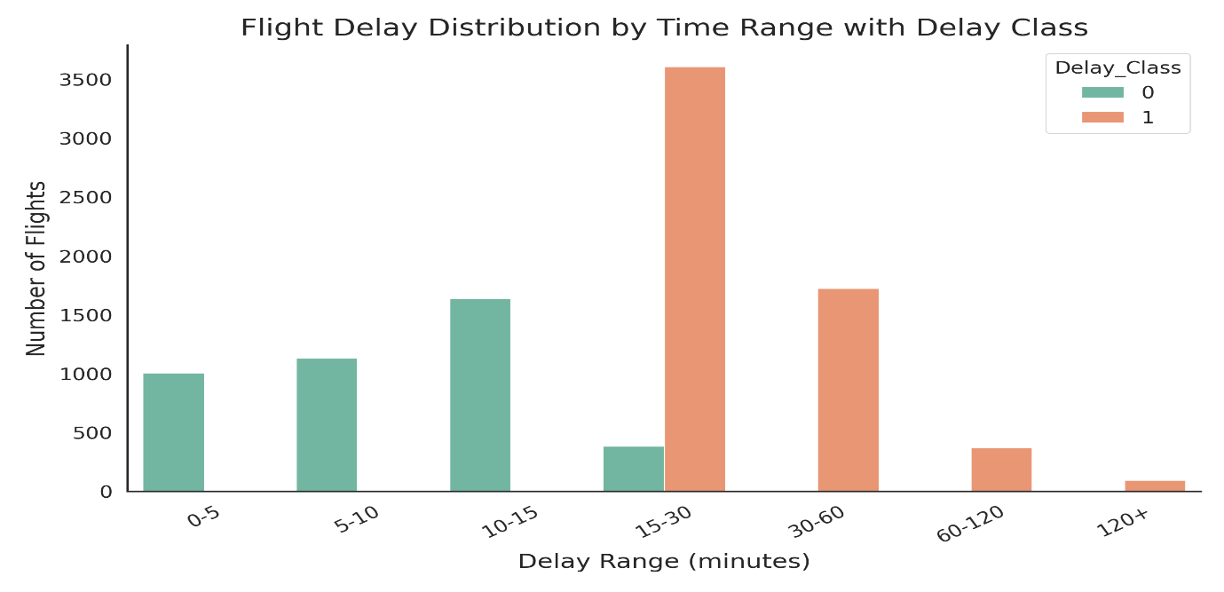
The figure suggests a clear demarcation between delayed and non-delayed flights. Most flights without delays are concentrated in the lower interval ranges (lower than 15 minutes), while delayed flights are concentrated in the higher delay range, especially 15–30 minutes. Passenger offerings on flights become less frequent the longer the delay is past 60 minutes. This implies extreme delays are rare.

Figure 3.2: Histogram showing the distribution of flight cancellation percentages

Current vs Previous Year Average Delay
The histogram plot shows the correlation between average delay minutes currently and the value of delays from last year. most of the data points are packed towards the lower range of both axes. This indicates that flights that were less delayed last year will also be relatively less delayed this year. Business is steady often suggests operational performance consistency over time.
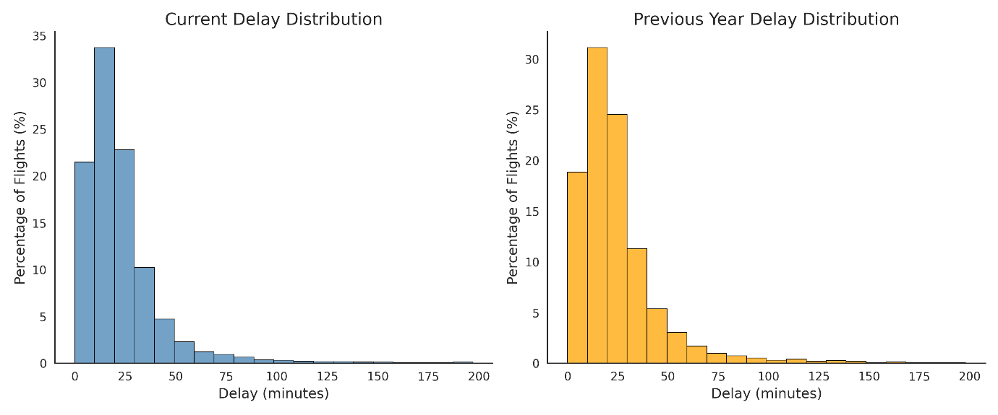
Figure 3.3: comparing current average delay with previous year average delay

Distribution of Average Flight Delay
The histogram shows the distribution of average delays minutes in flights. The delay distribution is highly right-skewed; that is, most flights are delayed by a few minutes and are mostly concentrated in a tight interval near zero. This means that in most cases, the enroute delays of flights are normal.
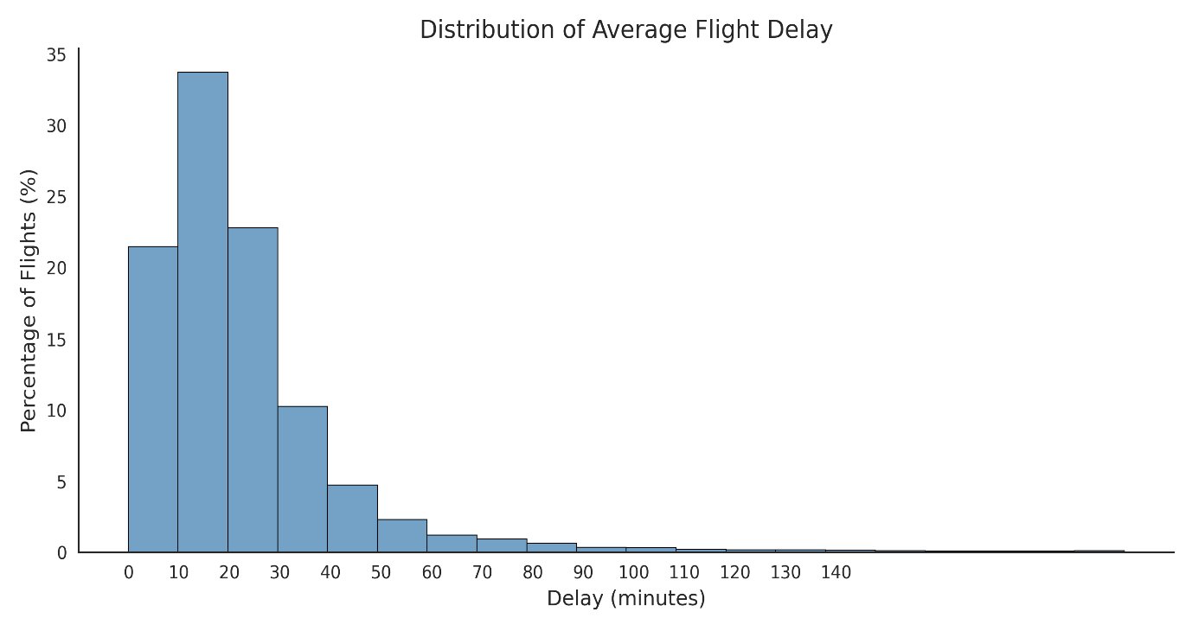
Figure 3.4: Histogram showing the distribution of average delay minutes

Correlation Heatmap
The heatmap or correlation matrix of the numerical variables is depicted in Fig. 3.3. There is a strong positive correlation in several features. The number of flights matched for this year is strongly correlated with the previous year flight counts (≈ 0.97). Likewise, average delay minutes are strongly correlated (about 0.75) with extreme delay categories (e.g. delays more than 360 minutes), indicating these serve as a significant source of average delay minutes.

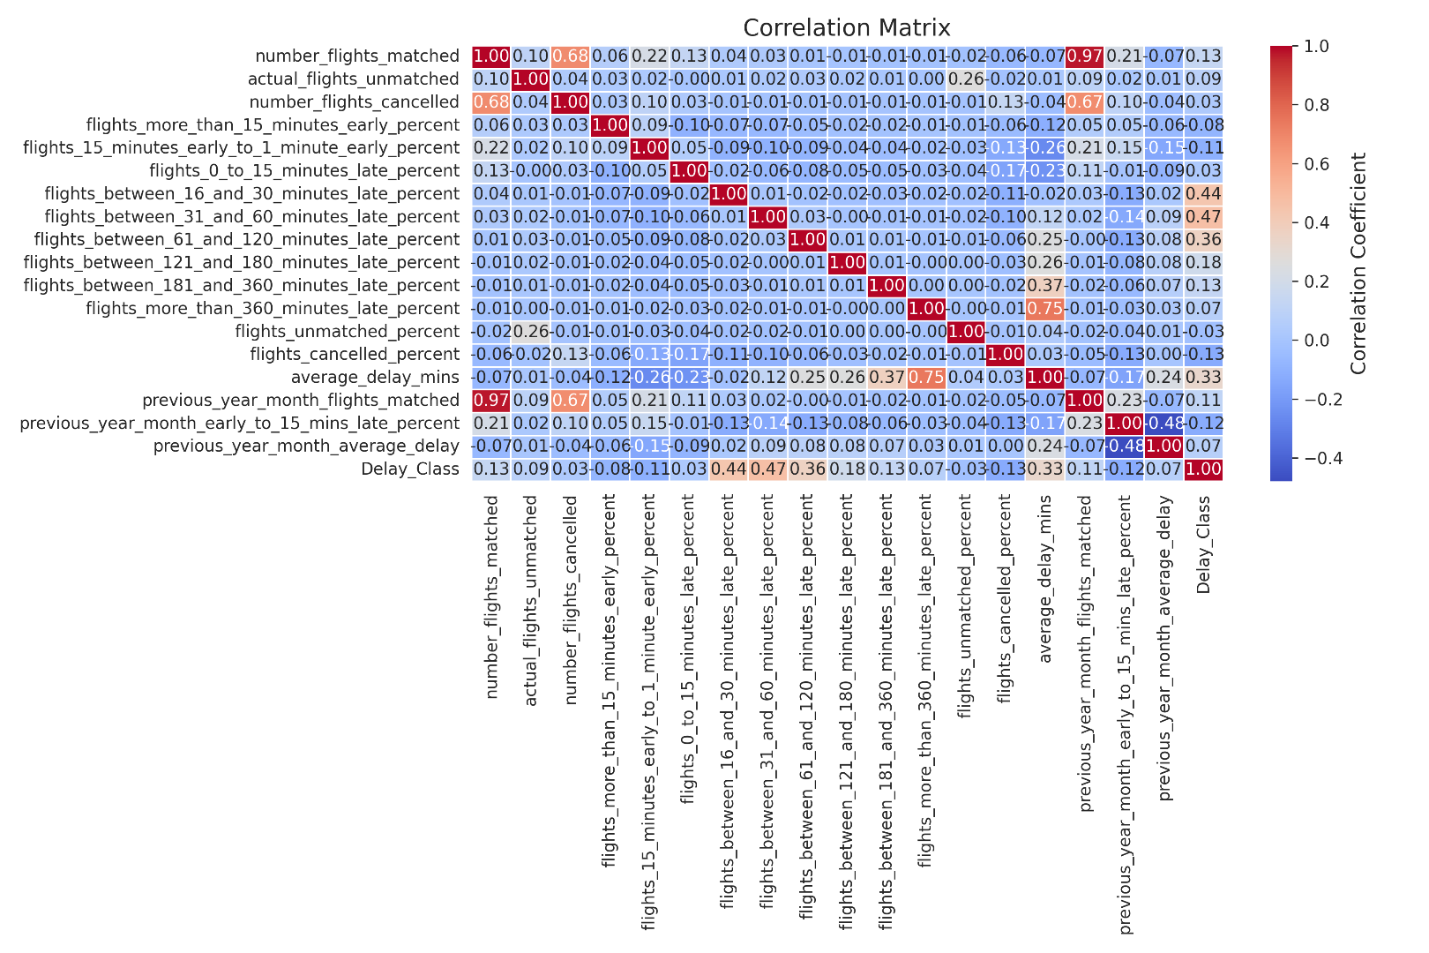
These findings show that delay-related variables in this model are multicollinear. In other words, there are multiple features that capture similar information. To overcome this, to enhance the efficiency of the model and reduce overfitting, highly correlated variables were chosen to be dropped during pre-processing.

Figure 3.5: Heatmap

Data pre-processing
NaN value recorded at average_delay_mins (3014), previous_year_month_average_delay (3221). These were dealt with via median imputation to safeguard data distribution. We converted categorical variables into numeric format and scaled the features using StandardScaler. To avoid noise and improve model performance, columns irrelevant to the dataset were removed.

Chapter 4: Ethical Consideration

Data Privacy and Anonymisation
The aviation performance data used in this research work is publicly available and does not contain any passenger or airline personnel-related information. All data objects such as flight counts, delays percentage, and airport-level information will utilize a set of operational level data that does not allow for identification of an individual. Because of this, information from the dataset is anonymously recorded and runs no risk of breaching personal privacy.

Ensuring that the analysis remains centred on how well an operation performed rather than on the individual-level information helps us keep things ethical. Moreover, no effort was made to re-identify or infer sensitive information from the dataset.

GDPR and Ethical Approval
This research is subjected to the General Data Protection Regulation (GDPR). However, since personal data is not processed, this Regulation does not apply. This dataset is fully anonymised and publicly available thus it does not fall under GDPR restrictions on personal data. Also, the study was not conducted on human beings or through a survey or primary data collection.
Thus, it doesn’t require any ethical approval from guidelines. The analysis is done only based on secondary data that are freely accessible for research purposes after complying with the legal and institutional norms. This study does not impose ethical risks regarding data privacy and participants consent.

Permission and Licensing
The data source used in the project is publicly available aviation data, which is used for academic and research purposes only. It is assumed that the data is shared under an open or permissive licence that enables its use for analysis only – not commercial exploitation or distortion. Credit for the data source is given wherever it is required. Utilizing such datasets is consistent with academic integrity policies and ensures transparency of research. No changes have been made in violation of the terms of use and moreover, the data has been appropriately treated in accepted research standards.

Ethical Considerations
The study's ethics relates to the responsible use of data, fairness and transparency. The dataset is public and does not contain any private or sensitive information, thus posing no privacy concerns. The first point to highlight is bias avoidance as if the data is imbalanced, the models would learn the wrong patterns. The other most relevant points include the transparency of features. It ensures all steps like data pre-processing, model building, evaluation, etc are well explained. Thus, it ensures the reliability of these features. Ultimately, the research is utilised for improving flight delay prediction and operational efficiency.

Chapter 5: Methodology

Overview of the Chapter
The methodological framework for developing machine learning models for predicting the delay of flights is presented in this chapter. The process adheres to a continuous series of actions, which cover actions from data and feature engineering to model development, fitment tuning, and evaluation. he main aim of this method is to convert raw aviation data into an accurate classifier of flight delays. The implementation was done in python using libraries like pandas, NumPy, scikit-learn, and matplotlib that helps in building the required data manipulation, model building and visualization.

Feature Engineering and Target Variable Definition
Prediction task is called the classification problem were.

The target variable (y) is Delay Class.
0= No Delay
1 = Delay

Delay percentages, average delay minutes, and previous year performance discuss how flight delays and hence were chosen as features. To make them compatible with machine learning models, categorical variables were converted into numerical variables using encoding.

Train-Test Strategy
The dataset was divided into two parts which consisted of.
80% training data
20% testing data
I employed random splitting to guarantee that both datasets reflect the overall data distribution. This process ensures that the model is tested on unseen data and ensures that the model is not overfitting.

Feature Scaling
The dataset was normalized using Standard Scaler.
- The scaler was fitted solely on training data.
- I modified the train and test data.
As a result, we ensure that all the features lie on the same scale, with the mean being zero and standard deviation one. Feature scaling aids in enhancing the performance of your model. The model parameters for algorithms like Logistic Regression are quite sensitive to feature scaling.

Model Development

Model | Technical Configuration | Working Principle | Reason for Selection
Logistic Regression | Default parameters, scaled input | Linear model using probability estimation | Simple, interpretable baseline model
Random Forest | n_estimators=100, random_state=42 | Ensemble of decision trees using bagging | Reduces overfitting and improves accuracy
XG Boost | learning rate=0.1, max_depth=6, n_estimators=100 | Gradient boosting with sequential learning | High accuracy and handles complex patterns

Table 5.1: Model Architecture and Configuration
These models were selected to study and compare predictive performance.
- A baseline model was created using Logistic Regression.
- Random Forest uses ensemble learning to improve performance.
- XG Boost increases accuracy by correcting prior mistakes.

Hyperparameter Tuning and Optimization

Model | Parameters Tested
Logistic Regression | C (0.1, 1, 10), solver (lbfgs), max_iter (1000, 2000)
Random Forest | n_estimators (100, 200), max_depth (10, 20, None), min_samples_split (2, 5)
XG Boost | learning_rate (0.01, 0.1), max_depth (3, 6), n_estimators (100, 200)

Table 5.2: Hyperparameter Search Space

Technical Explanation
I used GridSearchCV to optimize model tuning. I checked various combinations on hyperparameters for each model. To find the best parameters, cross-validation was applied. To prevent overfitting, the F1-score was chosen as the scoring metric to balance precision and recall.

Model Evaluation Metrics

Technical Explanation
I used several performance metrics to assess my models thoroughly. Accuracy measures overall performance, while Precision and Recall help understand prediction quality. The F1 Score balances both. We use ROC-AUC to quantify the model’s ability to separate delayed vs non-delayed flights.

Metric | Purpose | Why I Used It
Accuracy | Overall correctness | Measures overall model performance
Precision | TP / (TP + FP) | Avoid false positive predictions
Recall | TP / (TP + FN) | Important for identifying delayed flights
F1 Score | Harmonic mean of precision & recall | Balances precision and recall
ROC-AUC | Area under ROC curve | Measures classification performance across thresholds

Table 5.3: Evaluation Metrics and Justification

Model Validation
Five-fold cross-validation was applied to the model.
- I measured performance metric over the folds.
- The model was evaluated on multiple data splits.
- I made certain that the model worked well with new data.
By applying this strategy, overfitting can be minimized, and it will be evident that it generalizes well.

Performance Comparison Strategy
I compared all models using the following methods:
Accuracy, Precision, Recall and F1 Score
Confusion matrix for each model
ROC curve for model comparisonThis approach helps in identifying the best performing model based on both accuracy and prediction quality.

Explainable AI Implementation
In this study, it is possible to interpret the models through the important feature.
I examined the significance of characteristics for Random Forest and XG Boost.
I determined the essential factors behind delays.
The outputs of the model supported understanding of the prediction’s behaviour.
It provides interpretability, which enables us to assess the assertion feedback close to the actual reasoning.

Chapter 6: Results

Overview of Results
The aviation dataset is employed in this chapter to present the developed machine learning models in forecasting flight delays. The evaluation is done using multiple performance metrics: Accuracy, Precision, Recall, F1-score, and ROC-AUC Score of each model. Because the aim of the study is to accurately classify delayed and non-delayed flights, we make sure to approach Recall and F1-score in order to achieve a better understanding of the model’s ability to detect an actual delay. Both the baseline and optimized models are analysed for results to see how it was improved. In addition, cross-validation is used to assess the stability and generalization capacity of the models with different datasets. The Results of this chapter help in identifying the most reliable model for the flight delays prediction task and supports the aim and objectives of the study.

Initial Model Performance Analysis
Before optimization (Table 6.1), I evaluated the baseline models (Logistic Regression, Random Forest, and XG Boost). The study has shown that all models have high accuracy in predicting flight delays, though the classification of delays is somewhat different across models. Among the models, Logistic Regression performed the best in terms of accuracy followed by Random Forest and XG Boost having similar accuracy values but slightly lower than Logistic Regression. While the models demonstrated impressive precision, their recall values revealed variation, suggesting that certain models neglected some delay cases. The variance is essential since recall measures the capacity of the model which correctly identifies real delayed flights.

Model | Accuracy | Precision | Recall | F1 Score
Logistic Regression | 0.982328 | 0.985816 | 0.973730 | 0.979736
Random Forest | 0.965040 | 0.969616 | 0.950088 | 0.959752
XGBoost | 0.978486 | 0.981383 | 0.969352 | 0.975330

Table 6.1: Initial Model Performance

Optimized Model Performance Analysis
After hyperparameter tuning of the models, I obtained improved performances. The models that were optimized produced results which were found to have improved accuracy, precision, and recall when compared to the baseline results. Logistic Regression performed the best overall with high accuracy and balanced precision and recall values. After tuning the Logistic Regression which gave us a good advantage, however, performance of the Random Forest improved but was still slightly lower than the Logistic Regression. The findings show that tuning can help to improve model performance and stability. These findings support that the most effective model for predicting flight delays is Logistic Regression.

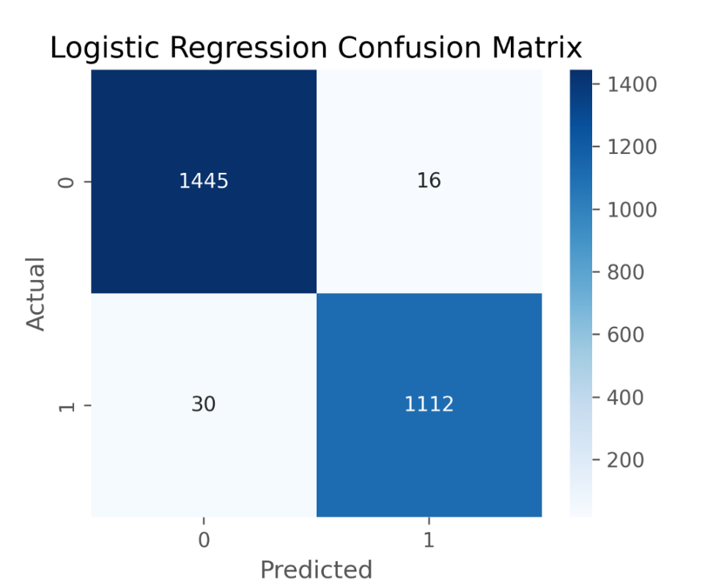
Figure 6.1: Logistic Regression Confusion Matrix

The confusion matrix (Figure 6.1) of the Logistic Regression model is good as most delayed and no-delayed flights are classified correctly. The model is highly accurate and makes very few mistakes. Comparisons of the ROC curves (Figure 6.2) show that Logistic Regression has the highest AUC value, indicating better separation. Random Forest and XGBoost performance is decent too, but slightly lower AUC. Overall, the visuals affirm the efficacy of the optimized models.
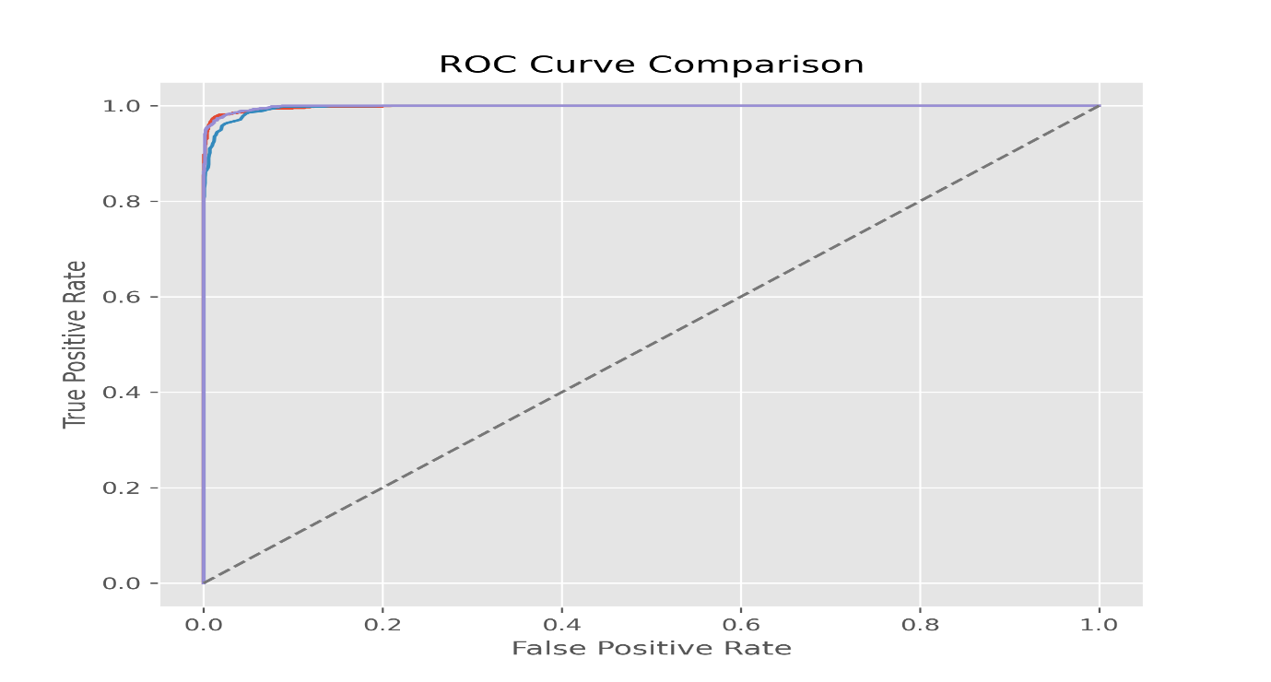
Figure 6.2: ROC Comparison

Model Accuracy Comparison
The comparison of model accuracies indicates that Logistic Regression has the highest accuracy among all other models. This shows that the model is the best one to predict flight delay. Random Forest and XG Boost accuracy is good but less when matched with Logistic Regression accuracy. The results show that all the models work well together, but Logistic Regression gives the best prediction for our data.
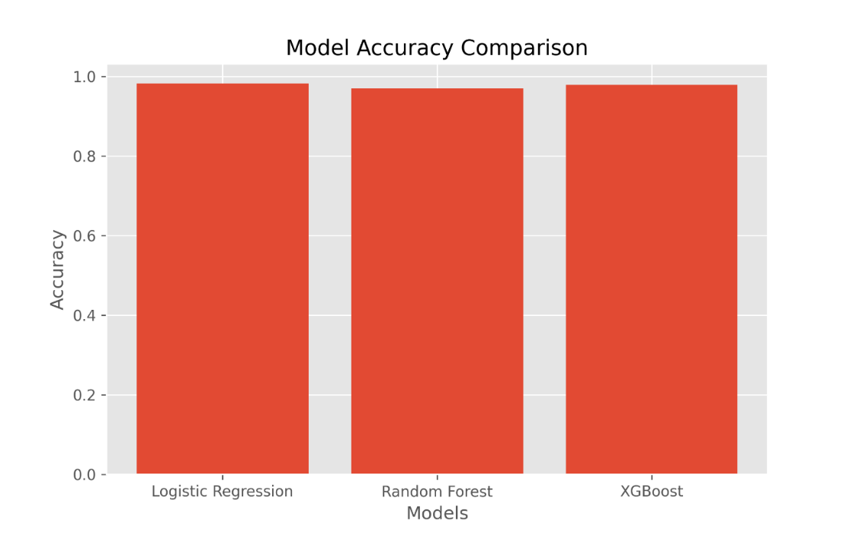
Figure 6.3: Model Accuracy comparision

Explainability and Feature Importance
A Random Forest model was designed and used to perform feature importance analysis. This technique identifies the most significant predictor variables of flight delay.
Figure X displays the most essential features ranked by importance. The analysis revealed that the most important predictor was average delay minutes. The delay percentage features were next in importance, including 31–60mins delayed flights and 16–30 mins delayed flights.
Hence, both overall delay severity and mid-range delay categories are useful in determining whether an airline is classified as delayed. Moreover, historical predictors are also included in the prediction, such as the previous year average delay.
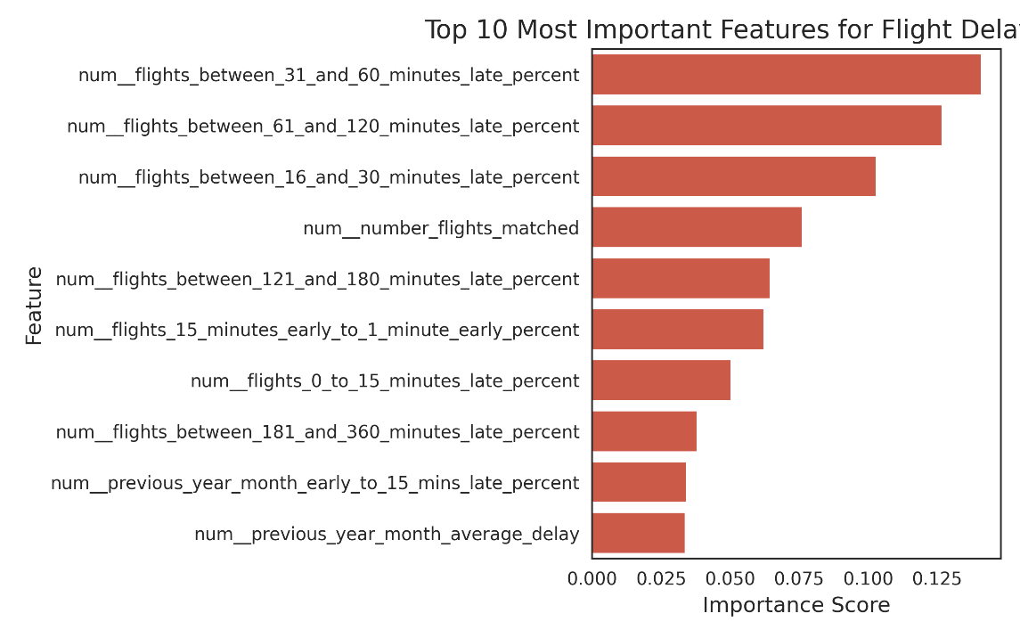
Figure 6.4:Top 10 Most Important Feature for Flight Delay

Chapter 7: Analysis & Discussion

Analysis of result
The performance varies across the selected machine-learning algorithms as observed from the results of the models. In terms of accuracy, Logistic Regression performed better than all other models, demonstrating that the dataset is significantly structured enough for a simple model to learn from it. The Logistic Regression showed a better performance as compared to Random Forest and XG Boost. The difference in recall values indicates that a few models could not identify delays for all the flights. This is important as missing delay cases can cause wrong decision making. In general, the Logistic Regression shows the most stable and reliable performance for this dataset.

Analysis of Explainability
The models employed in this study can be reasonably interpreted, which is crucial for understanding prediction behaviour. Logistic Regression indicates how chances of an event relate to the predictors of it. The feature importance score provided by both Random Forest and XG Boost helps identify the most significant factors causing delays. The predictors are influenced a lot from the delay percentages, average delay minutes and last year performance predictors. As a result, the model outcomes can be deciphered and utilized in real-world scenarios.

Comparison of result with literature
The results agree with the prior studies on delay prediction for various flights. Random Forest and XG Boost, which are ensemble models, generally have high accuracy, as shown by the previous study, due to their ability to capture complexities. Logistic Regression is a better option than a complex model when the relations in data are clear. This implies that a model cannot be chosen only based on its complexity. It is important to choose models which reflect the underlying data pattern. Machine learning models also provide better predictions than standard models, the findings confirm.

Practical Implication
Major takeaways of this study will strengthen operations in the aviation industry. The prediction of flight delays can provide airlines with a competitive advantage when it comes to scheduling. Anticipating delays helps the airline take necessary actions to minimize their impact on flight operations. Utilizing machine learning models allows for a dependable and expandable response that can be incorporated into actual systems for better decision-making.

Research Questions Addressed
The investigation successfully addressed the queries raised in the study by pinpointing the best-performing ML model for flight delay forecasting. The Logistic Regression model was found to be the best in terms of accuracy and stability. More importantly, the result indicates that the machine learning models can enhance the prediction accuracy supporting the main aim of research.

Chapter 8: Conclusion
Using historical aviation performance data from the UK Civil Aviation Authority, this study developed and evaluated multiple machine learning models for predicting flight delays. The results show that Logistic Regression achieved the highest overall performance, demonstrating superior accuracy and stability compared to Random Forest and Gradient Boosting models.

This finding is notable because it contrasts with prior studies such as Belcastro L., where ensemble methods typically outperform simpler models. In this study, the strong performance of Logistic Regression suggests that the dataset exhibits relatively linear separability, and that careful preprocessing and feature selection can significantly influence model effectiveness.

Feature importance analysis further revealed that average delay minutes and delay percentage variables are the most influential predictors, while historical features such as previous year delay performance also contribute to prediction accuracy. This confirms that both current operational conditions and temporal patterns play a critical role in determining flight delays.

The use of multiple evaluation metrics, including precision, recall, F1-score, and ROC-AUC, along with five-fold cross-validation, demonstrates that the models generalise well to unseen data. However, the results also indicate that high accuracy alone is insufficient, particularly in the presence of class imbalance, where recall and F1-score provide a more reliable assessment of model performance.

From a practical perspective, the findings highlight the potential of machine learning models to support airline decision-making by improving scheduling efficiency, reducing operational disruptions, and enhancing passenger experience.

Nonetheless, this study has several limitations. The dataset is bereft of external factors like weather conditions and operational disruptions, known to have a huge impact on flight delays. Further, though Logistic Regression gave us an excellent performance, more complex models may work better when we apply them on larger and diverse datasets.

Future work should focus on incorporating additional data sources, such as weather and real-time flight information, as well as exploring advanced modelling techniques, including deep learning approaches. Further research into explainability methods could also improve the transparency and practical adoption of machine learning models in aviation systems.

References

- Bishop, C.M. (2006) Pattern recognition and machine learning. New York: Springer.
- Breiman, L. (2001) ‘Random forests’, Machine Learning, 45(1), pp. 5–32.
- Chen, T. and Guestrin, C. (2016) ‘XGBoost: A scalable tree boosting system’, Proceedings of the 22nd ACM SIGKDD International Conference on Knowledge Discovery and Data Mining, pp. 785–794.
- Goodfellow, I., Bengio, Y. and Courville, A. (2016) Deep learning. Cambridge: MIT Press.
- Hyndman, R.J. and Athanasopoulos, G. (2018) Forecasting: Principles and practice. 2nd edn. Melbourne: OTexts.
- James, G., Witten, D., Hastie, T. and Tibshirani, R. (2021) An introduction to statistical learning. 2nd edn. New York: Springer.
- Kuhn, M. and Johnson, K. (2013) Applied predictive modeling. New York: Springer.
- Pedregosa, F. et al. (2011) ‘Scikit-learn: Machine learning in Python’, Journal of Machine Learning Research, 12, pp. 2825–2830.
- Belcastro, L., Marozzo, F., Talia, D. and Trunfio, P. (2016) ‘Using scalable data mining for predicting flight delays’, ACM Transactions on Intelligent Systems and Technology, 8(1), pp. 1–20.
- Rebollo, J.J. and Balakrishnan, H. (2014) ‘Characterization and prediction of air traffic delays’, Transportation Research Part C: Emerging Technologies, 44, pp. 231–241.

Apendex :
